Graded Assignment on Travel Memory Application Deployment

A **MERN stack application** is a web application built using the **MERN stack**, which stands for four core technologies: **MongoDB**, **Express.js**, **React.js**, and **Node.js**. This stack is commonly used for building full-stack, single-page web applications (SPAs) that are both fast and scalable.

Travel Memory consists of Backend & Frontend with backend connecting to mongodb database

**MongoDB Configuration:**

1. Setup account in mongodb and create a cluster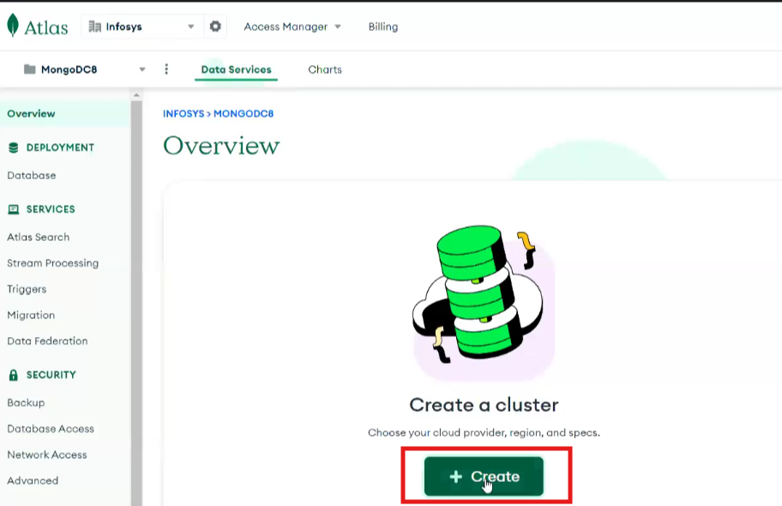

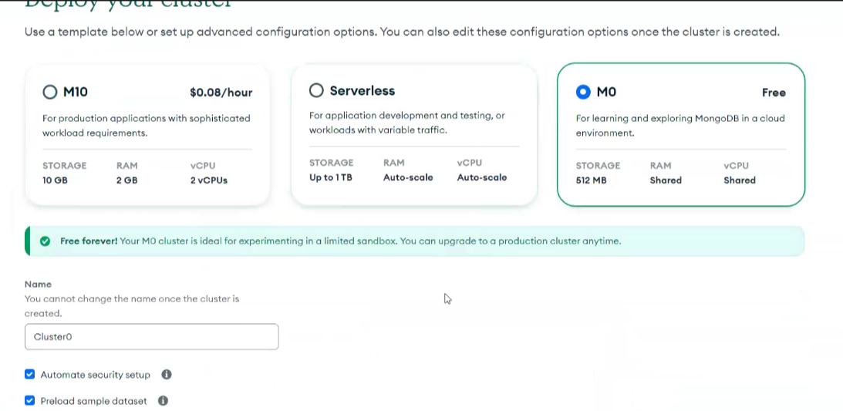

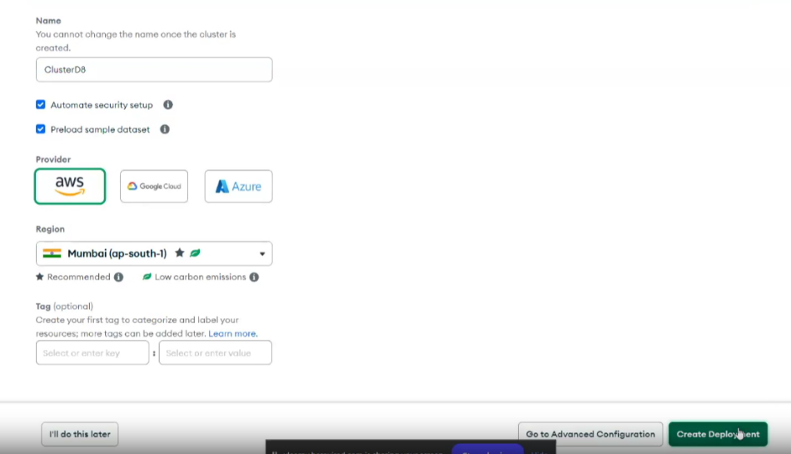

1. Copy the password safely as it needs to be used further and click on ‘Create Database User’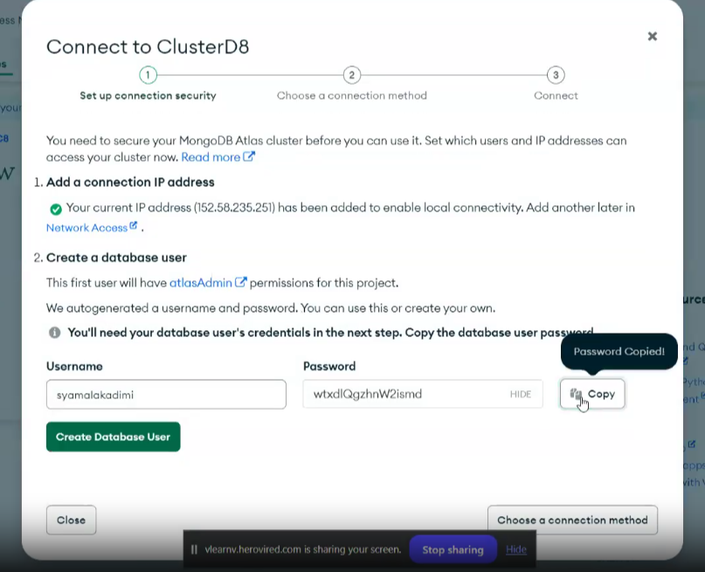

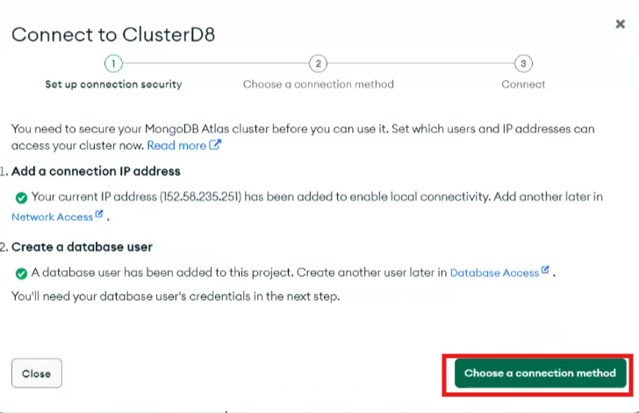

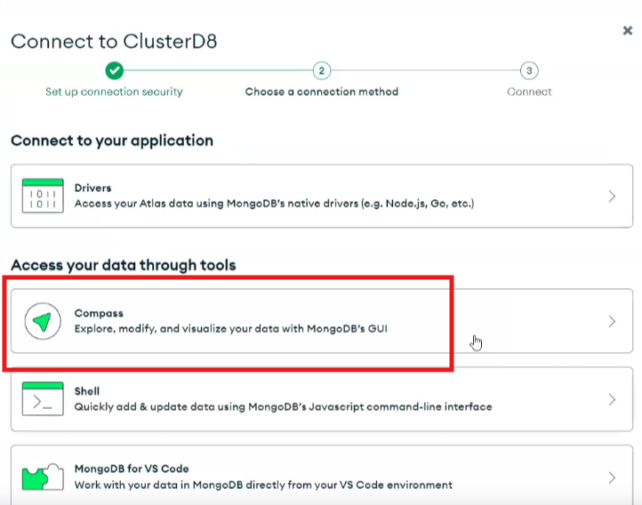

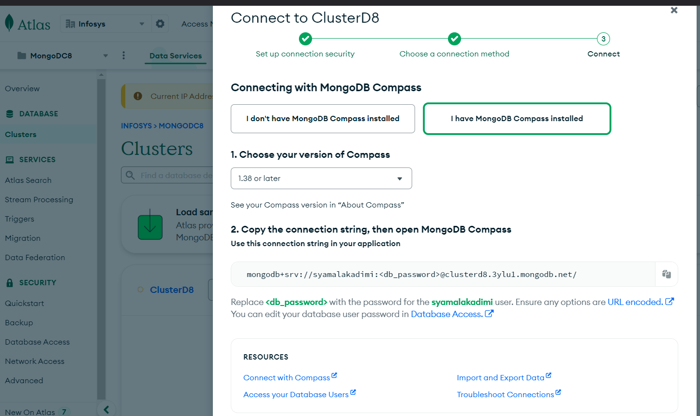

1. Open MongoDB Compass desktop version, add new connection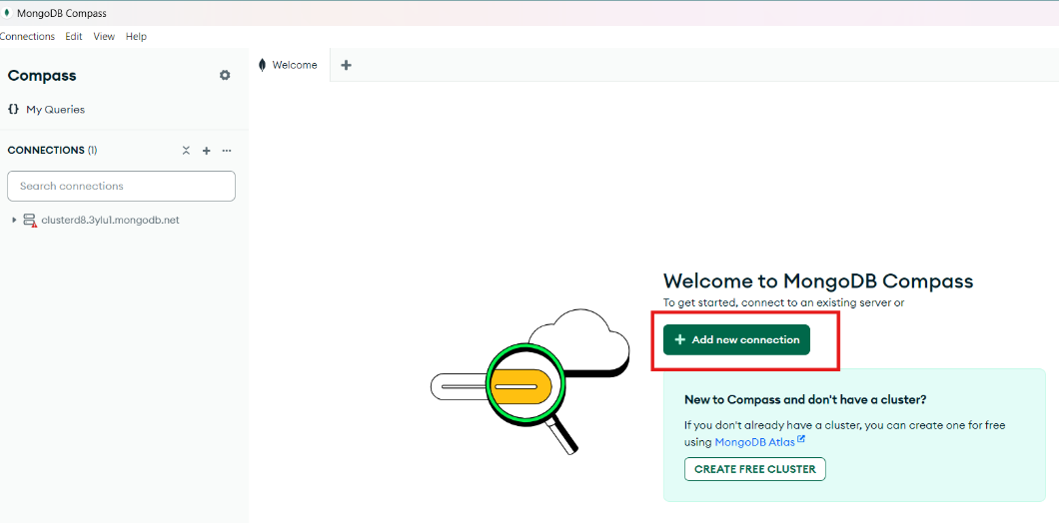
2. Connect to the DB using connection string. Copy the connection string along with password for further use during backend configuration

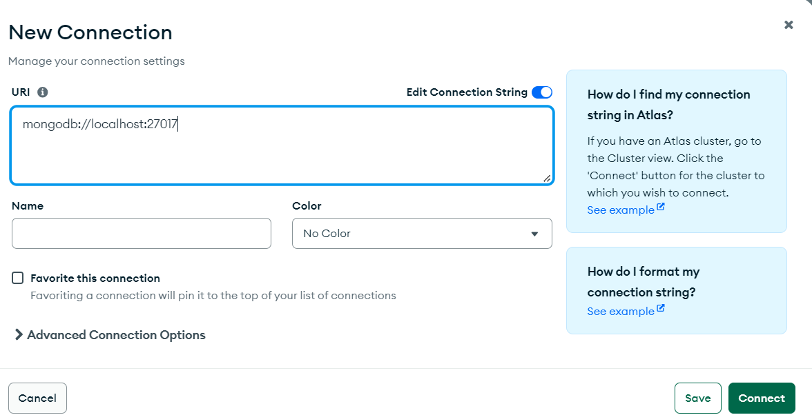

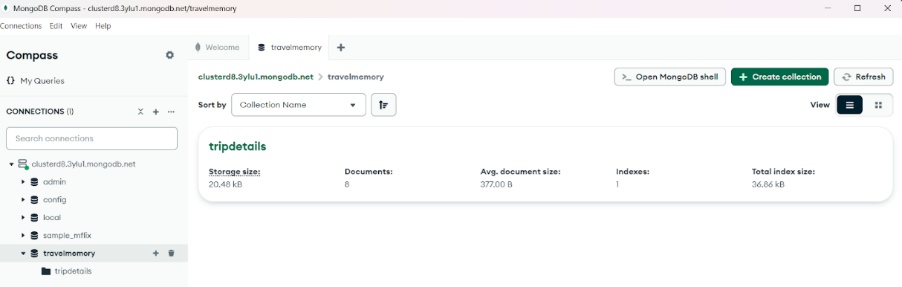

**Backend Configuration**

1. Navigate to <https://github.com/UnpredictablePrashant/TravelMemory>  and fork into your account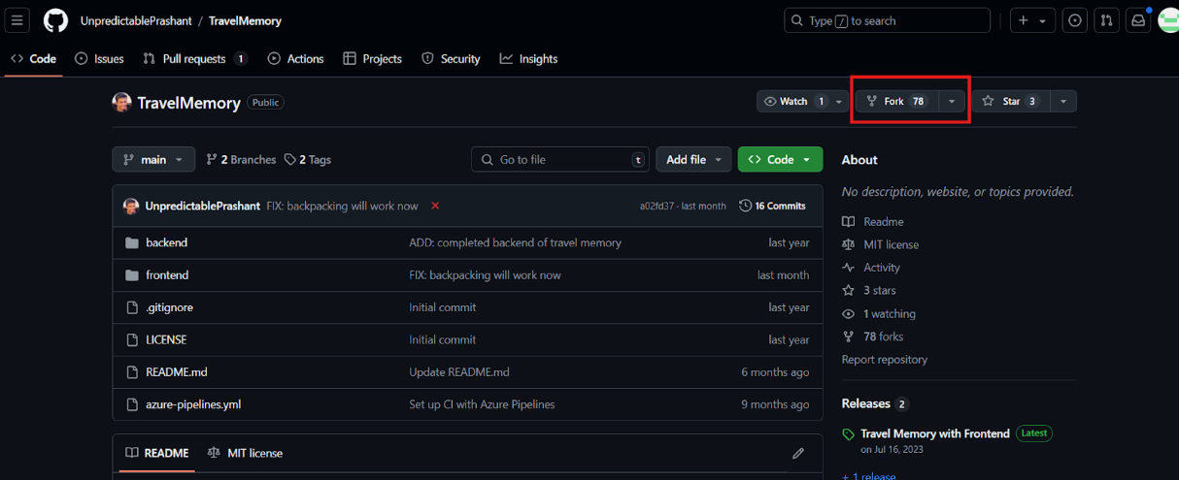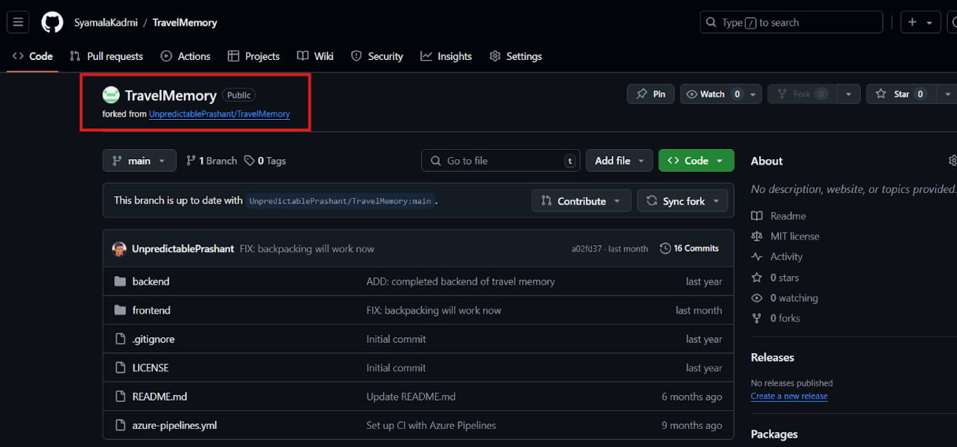
2. Create a t3.micro EC2 instance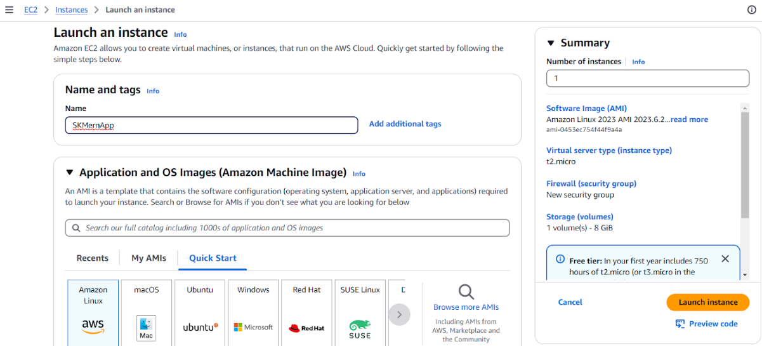

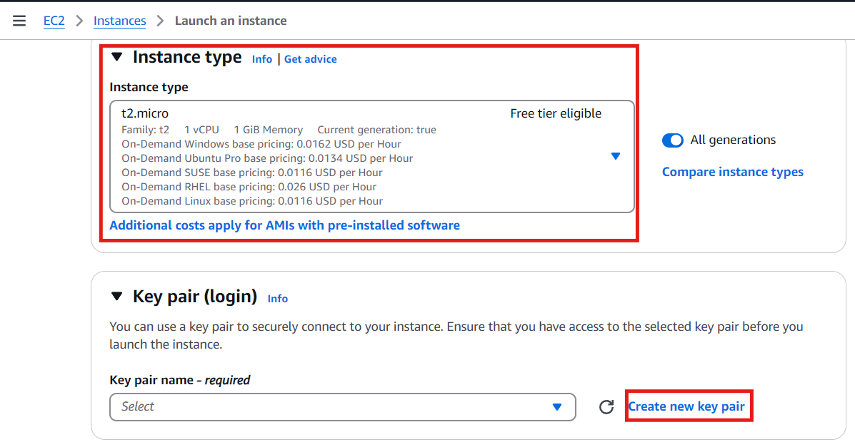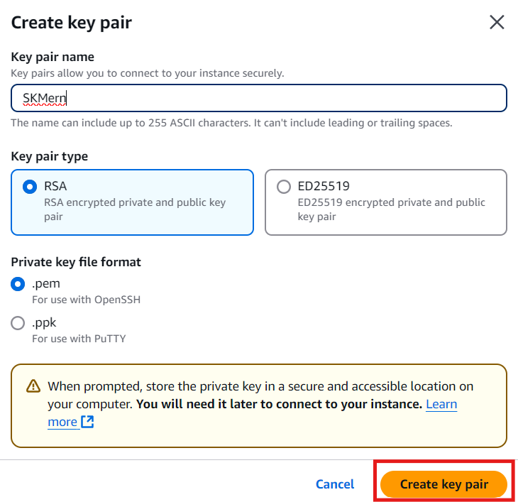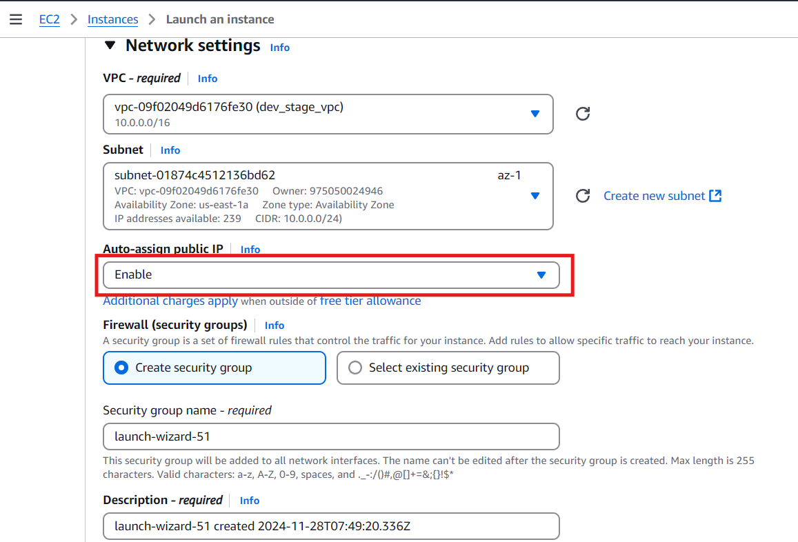

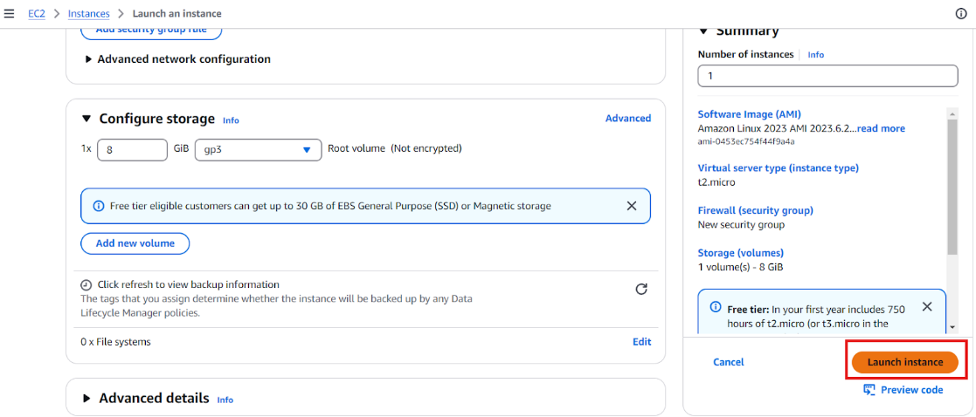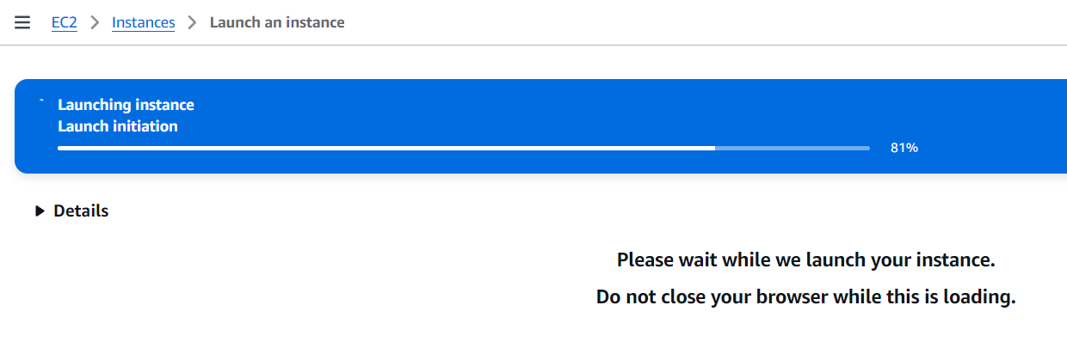

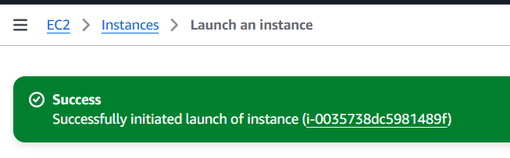

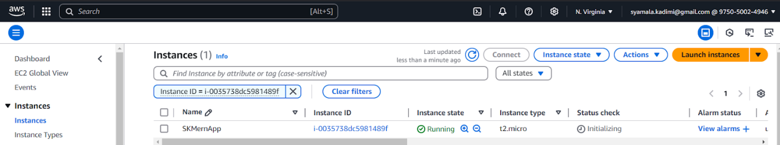

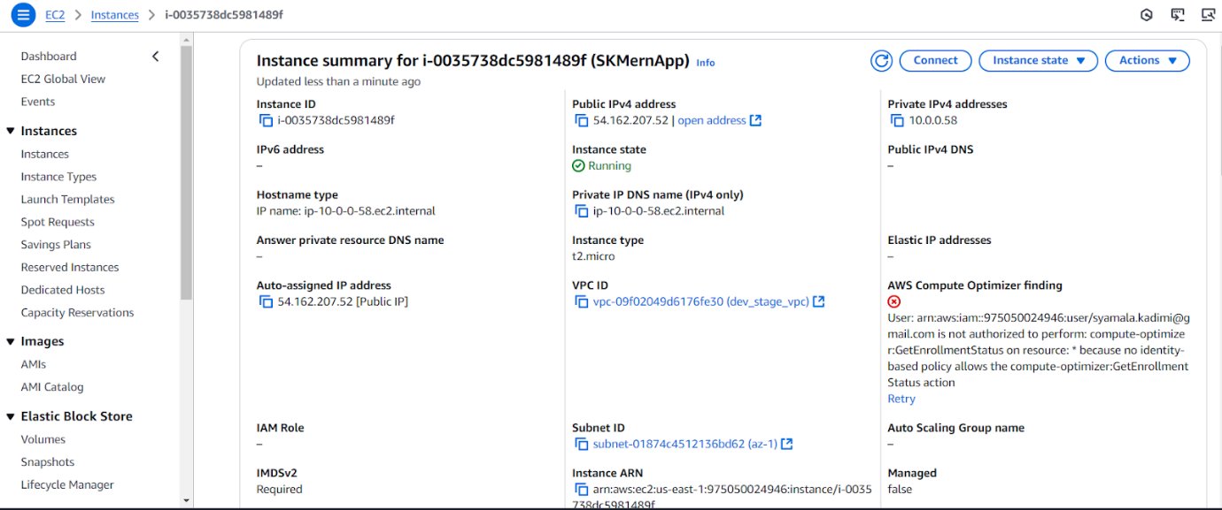

This particular MERN application backend is hosted on 3001 port & frontend on 3000. So, make sure these ports are added to the inbound rules of security group

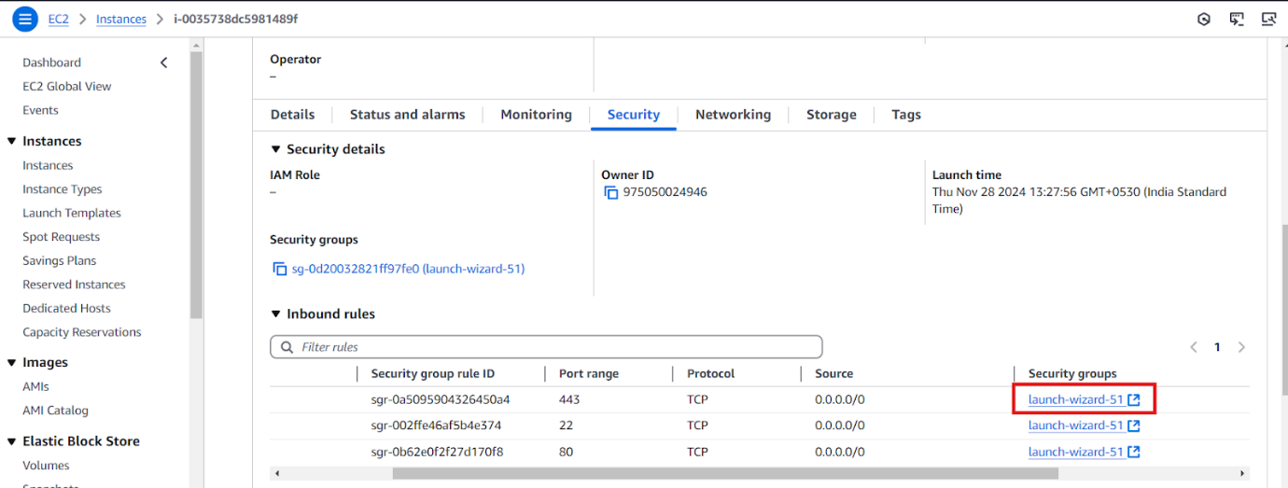

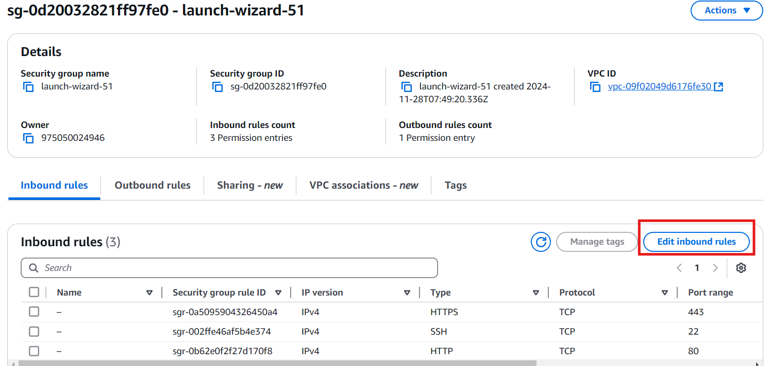

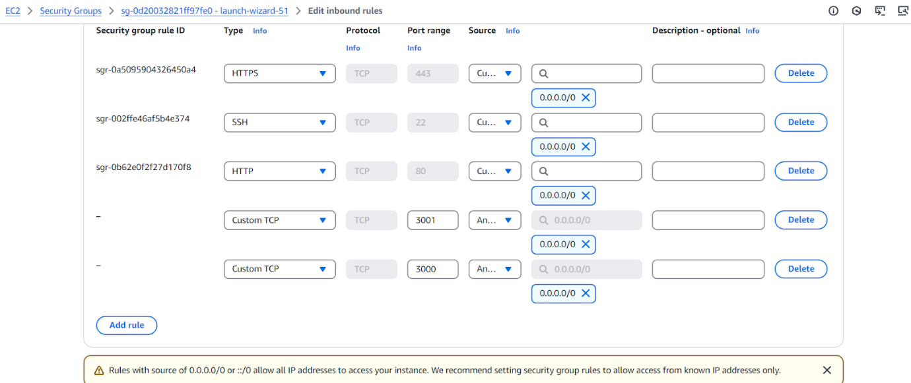

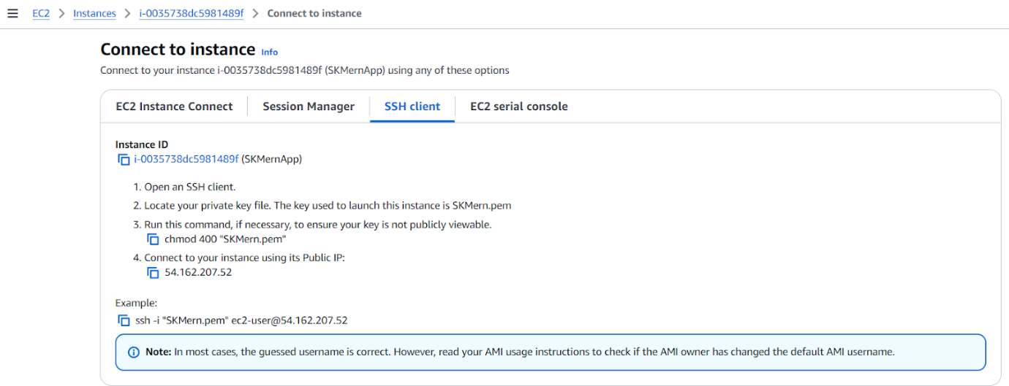

1. Open PowerShell to connect to EC2 instance via SSH
2. Copy the pem file to the instance
3. Set permissions to file

  sudo chmod 400 ‘filenema.pem’

1. Execute the below command

ssh -i "SKMern.pem" ec2-user@54.162.207.52

1. Once logged in, install nodejs, git

Sudo yum install -y nodejs

Sudo yum install -y git

1. Install nginx

sudo yum install nginx -y

sudo systemctl start nginx

sudo systemctl enable nginx

1. Validate the status of nginx installation by clicking http://<publicIPAddress>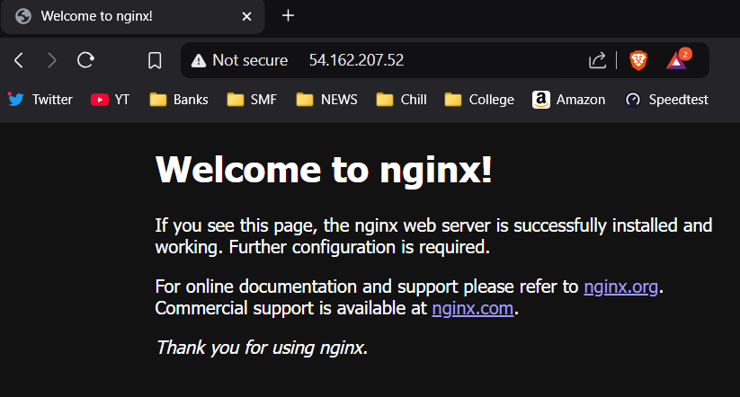
2. Clone your github repository using

Git clone<https://github.com/SyamalaKadmi/TravelMemory.git>

1. Navigate to the cloned repository -> backend folder and create .env file
2. Copy the connection string & paste it in .env file created under backend folder

MONGO_URI=mongodb+srv://syamalakadimi:<password>@[clusterd8.3ylu1.mongodb.net/travelmemory](http://clusterd8.3ylu1.mongodb.net/travelmemory)

PORT=3001

1. Run the backend end application using

node index.js &  #To run in detached mode

1. Replace localhost with the EC2 public ip address and verify the backend application is running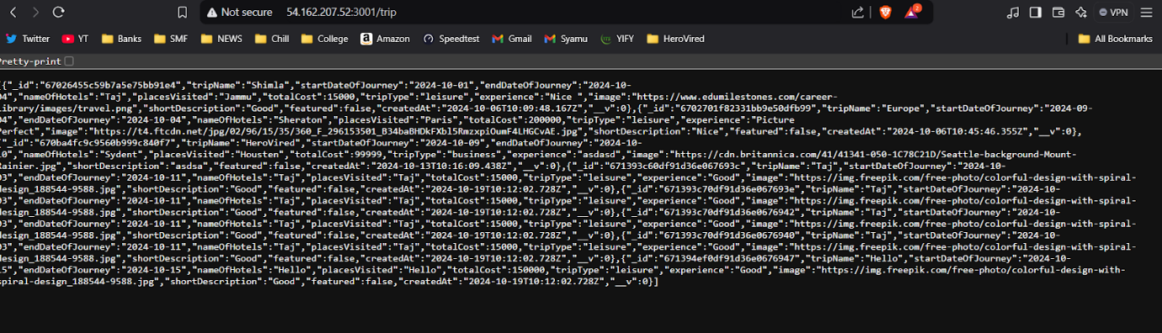

**Frontend Configuration:**

1. To setup frontend, navigate to frontend folder and create .env file

sudo vi .env

1. In the .env file, enter

REACT_APP_BACKEND_URL= [http://localhost:3001/](http://3.94.89.157:3001/)

1. Run below commands to start the frontend application

npm install

npm start &

And navigate to http://<ipaddress>:3000 to view frontend

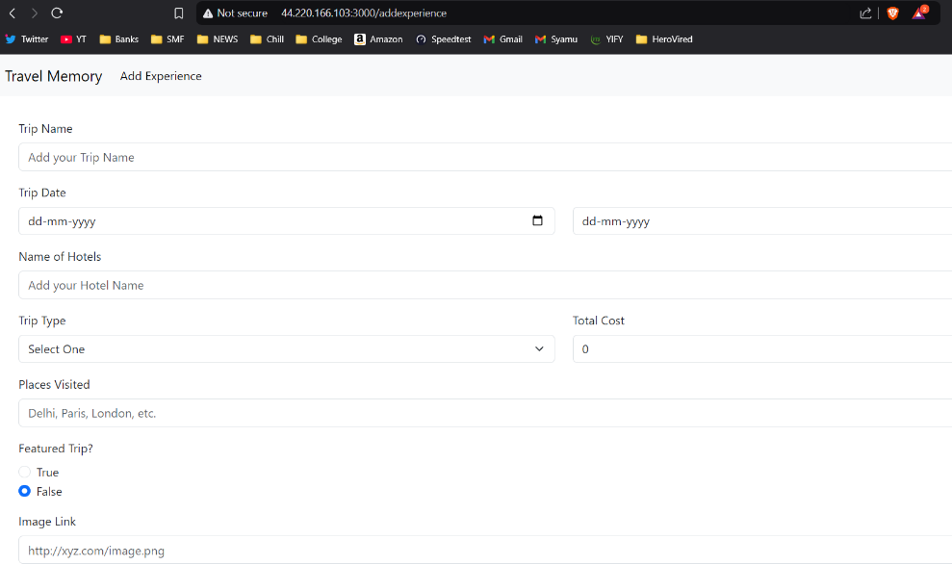

**Backend & Frontend connection using nginx reverse proxy**

1. Setting up reverse proxy

cd /etc/nginx/conf.d/

sudo nano reverse-proxy.conf

1. Add the following configuration

server {

     listen 80;

     server_name mernApi.syamalakadimi.cloud/

     # Frontend configuration

     location / {

         proxy_pass http://localhost:3000; # Forward requests to the frontend app

         proxy_http_version 1.1;

         proxy_set_header Upgrade $http_upgrade;

        proxy_set_header Connection 'upgrade';

         proxy_set_header Host $host;

         proxy_cache_bypass $http_upgrade;

     }

# Backend API configuration

     location /trip/ {

         proxy_pass http://localhost:3001; # Forward requests to the backend app

         proxy_http_version 1.1;

         proxy_set_header Upgrade $http_upgrade;

         proxy_set_header Connection 'upgrade';

         proxy_set_header Host $host;

         proxy_cache_bypass $http_upgrade;

     }

}

1. Save the file and reload nginx

sudo systemctl reload nginx

**Scaling the applications:**

This can be achieved by setting up Elastic Load balancer & Autoscaling groups.

1. To start with, take the AMI of the configured instance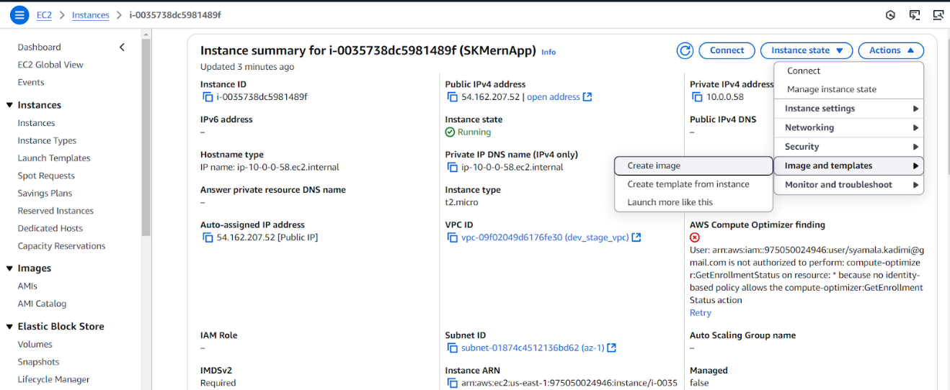

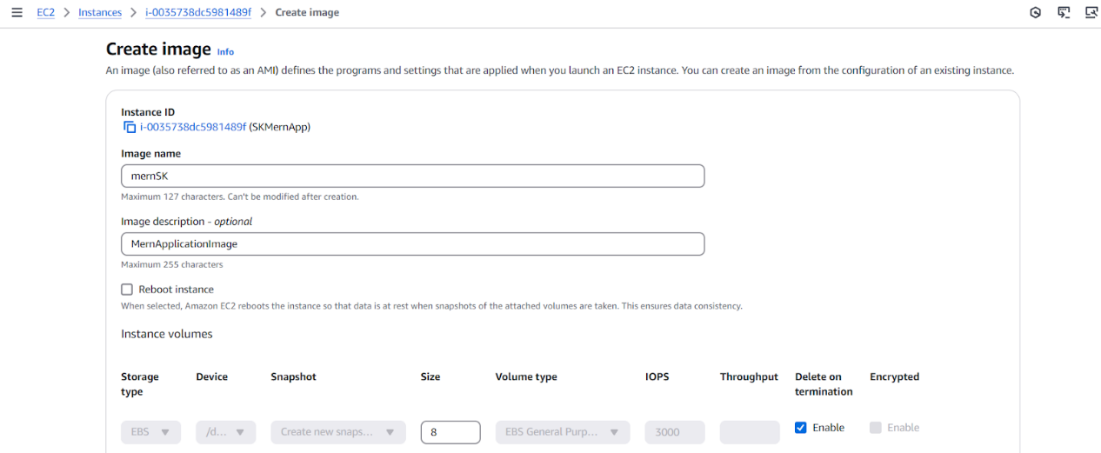

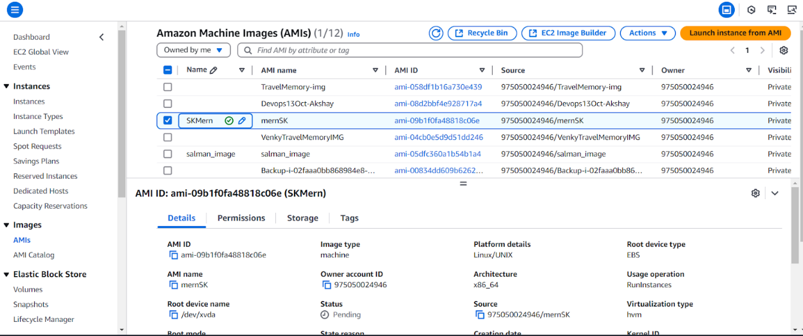

b. Create LoadBalancer -> Application Load Balancer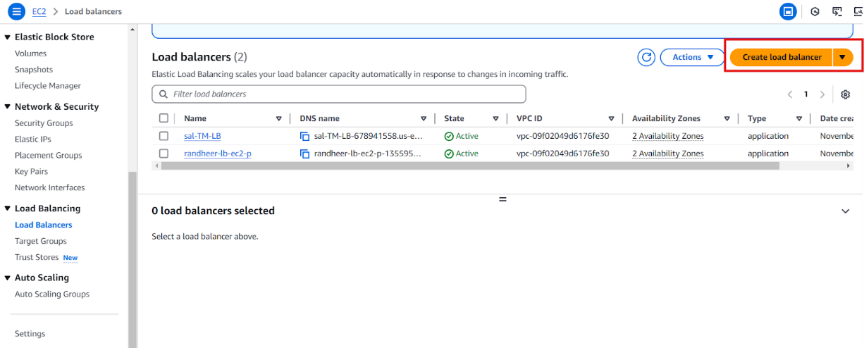

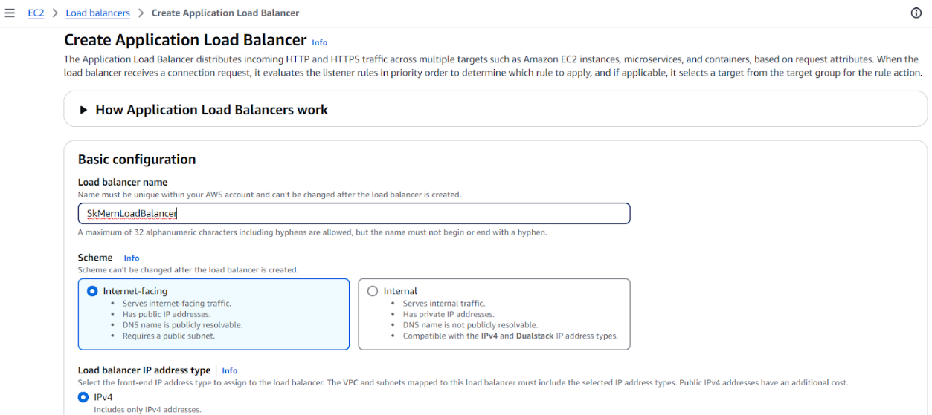

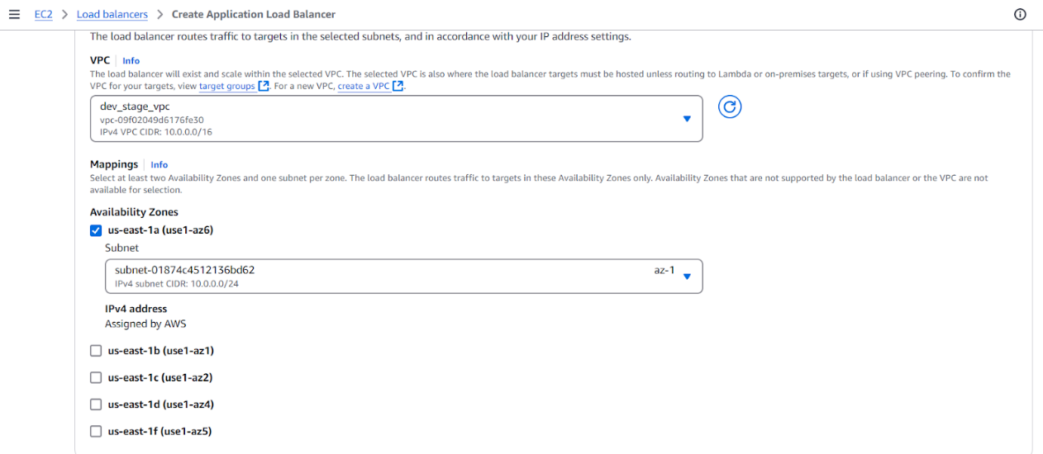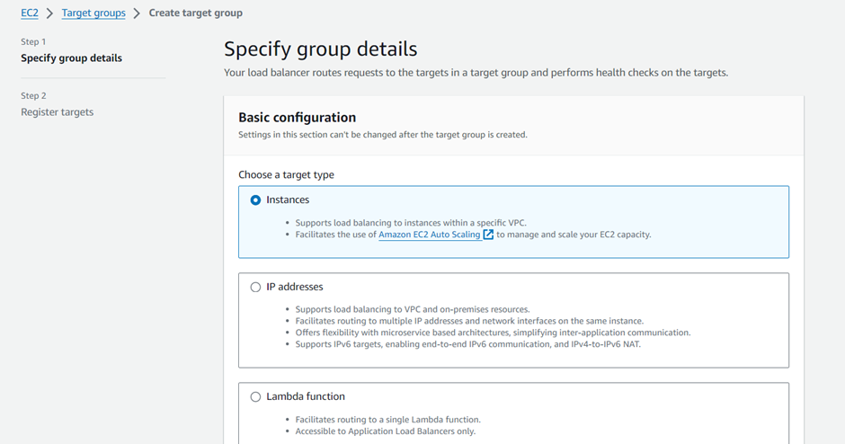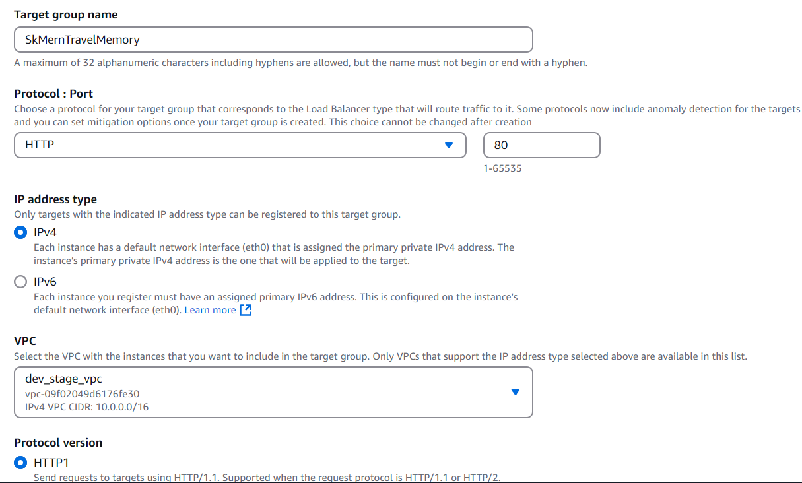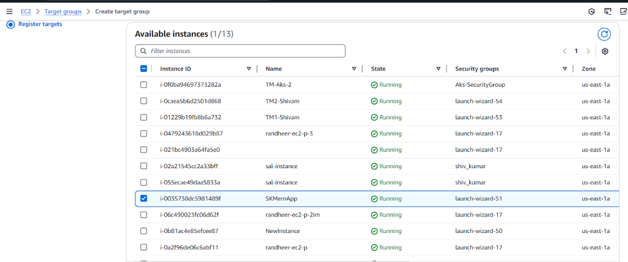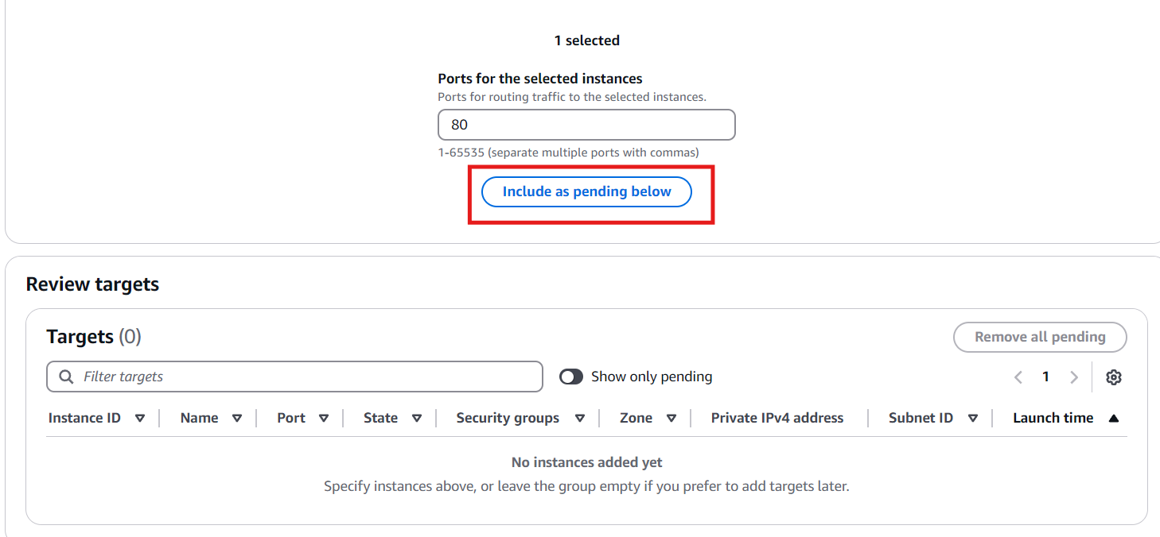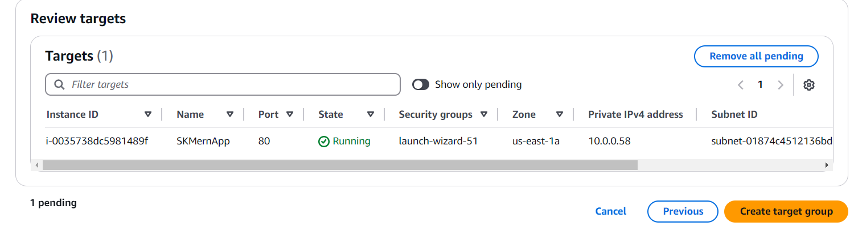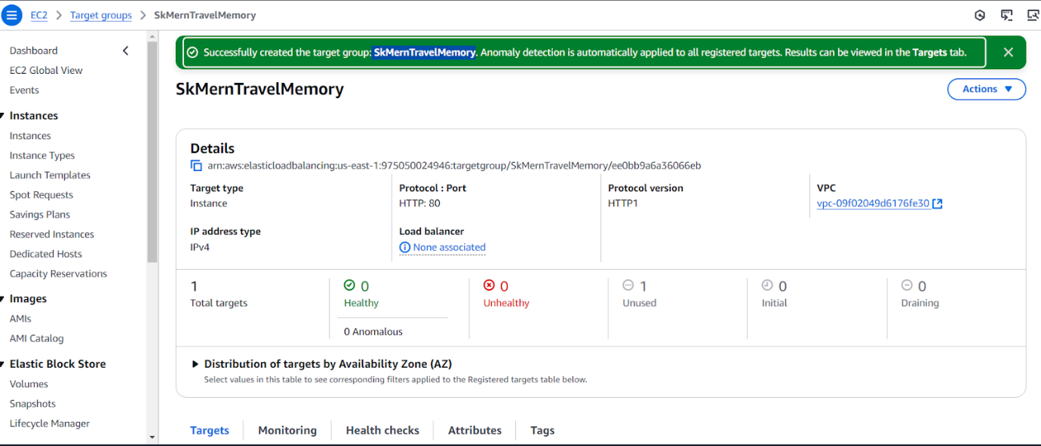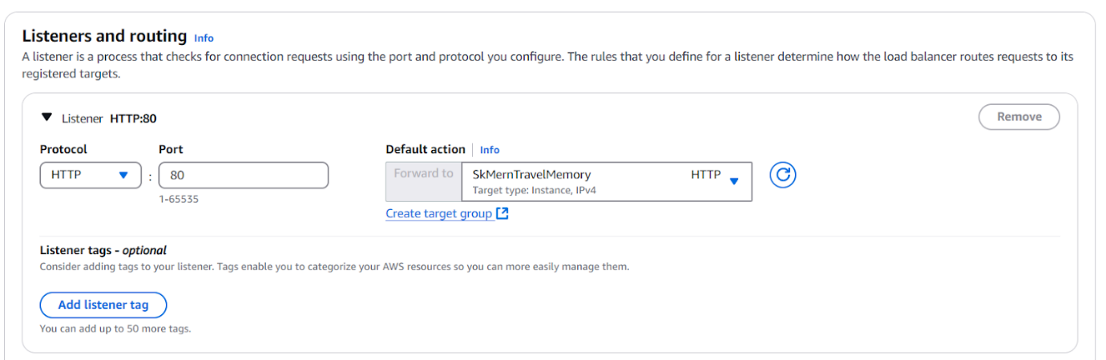

d. The highlighted dns can be used to connect to the application

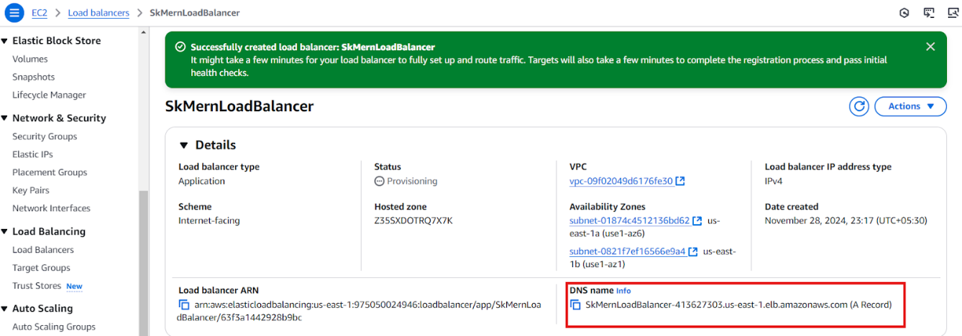

e. Create ASG 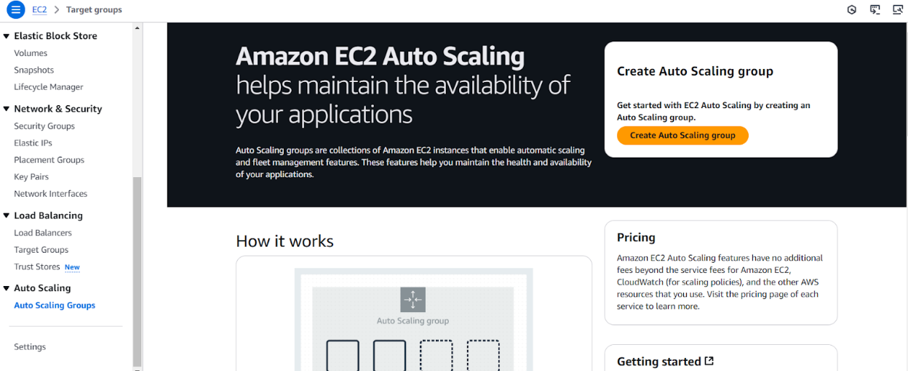

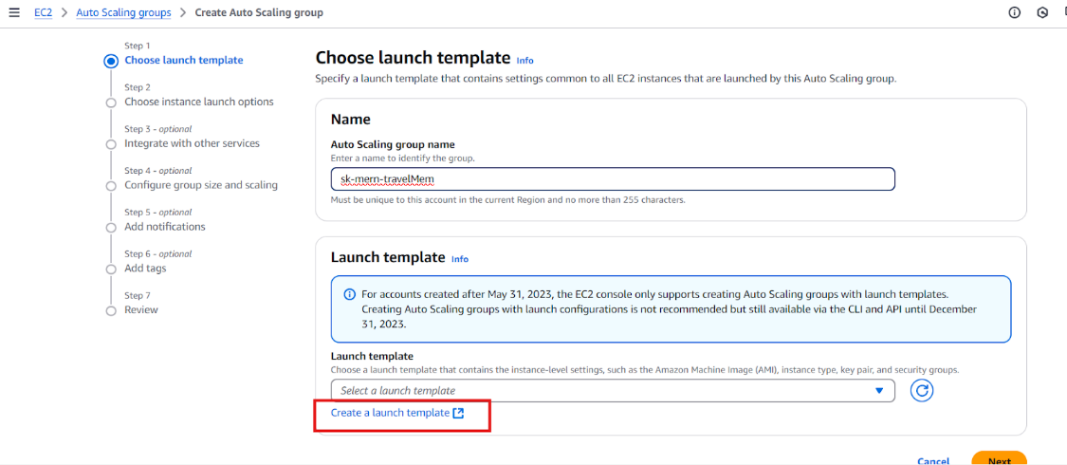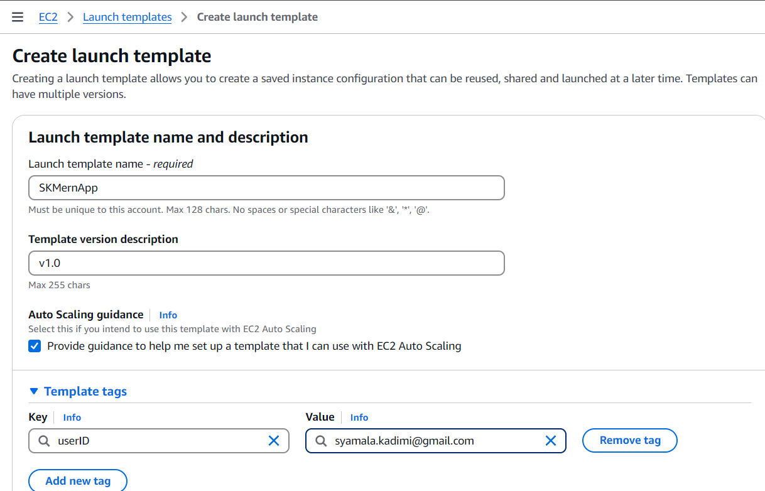

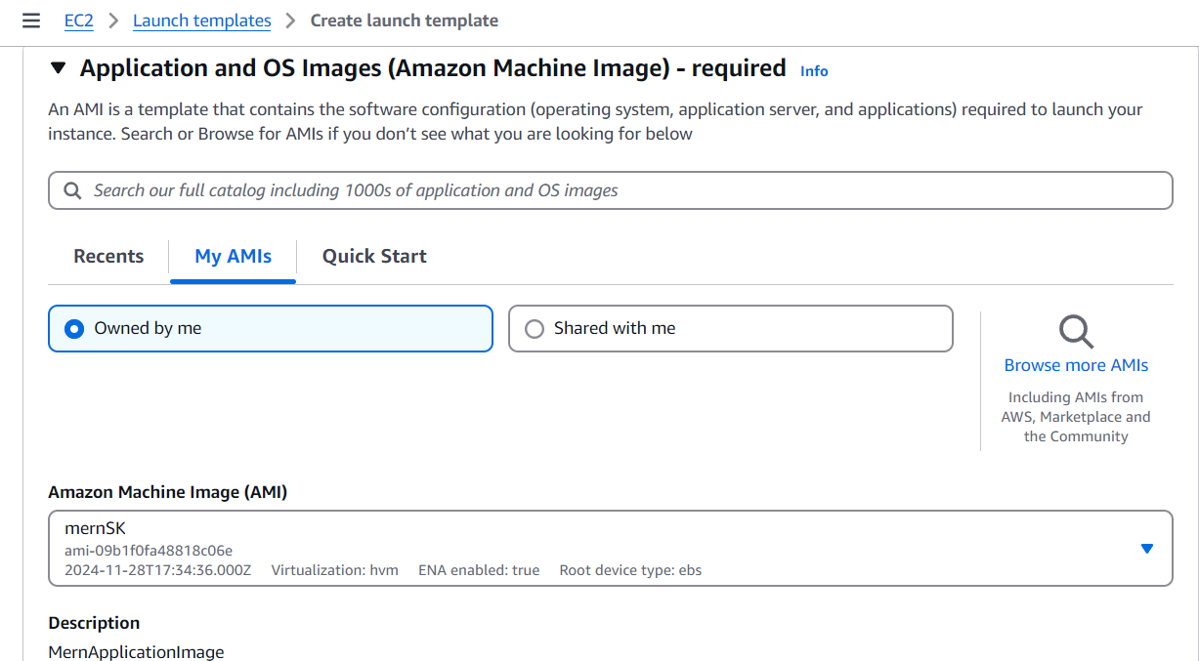

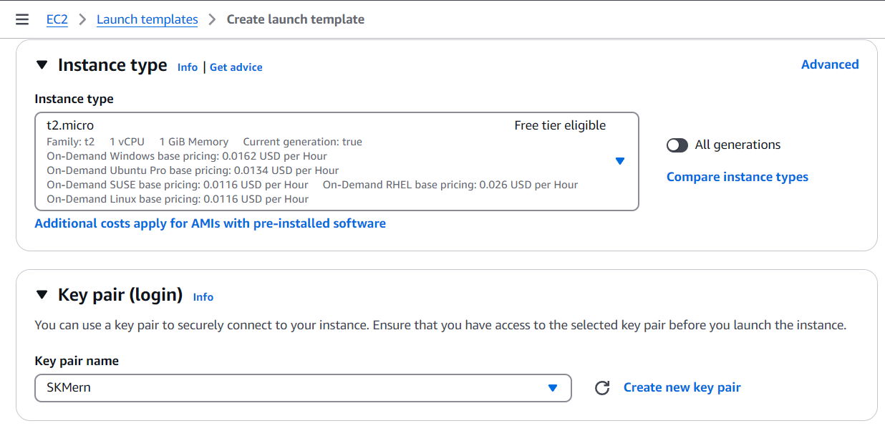

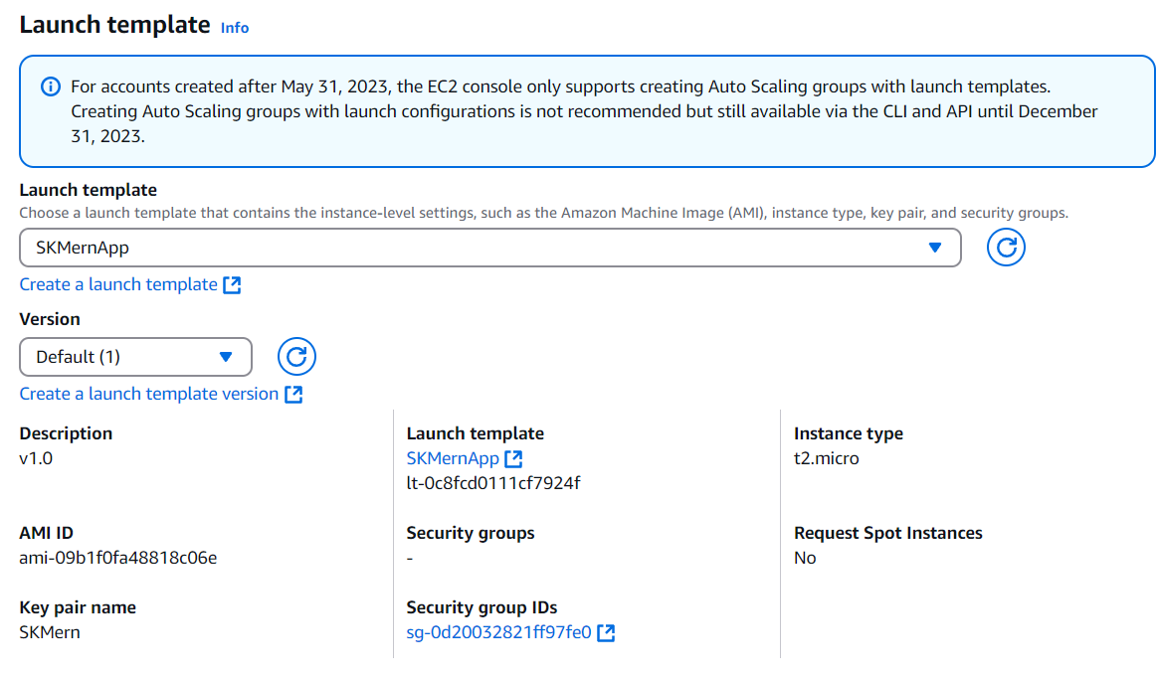

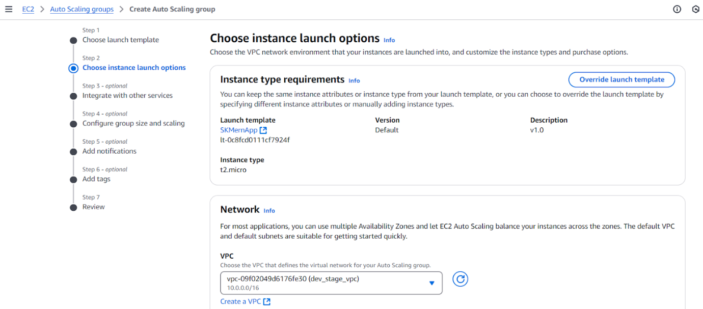

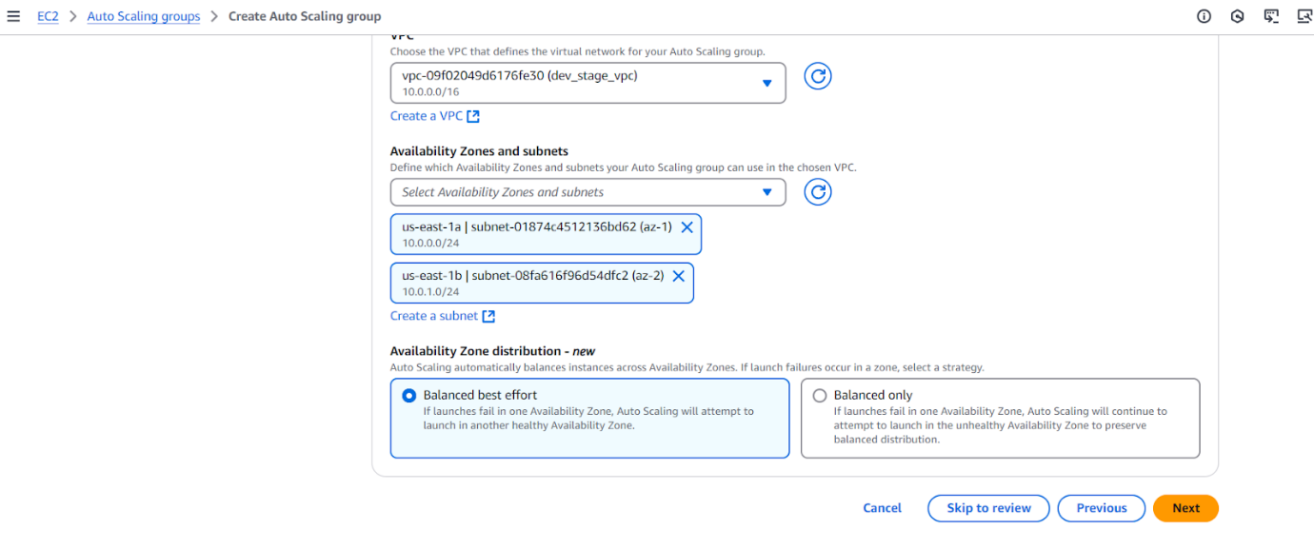

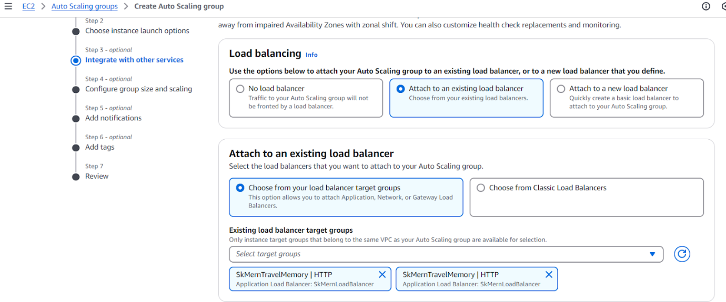

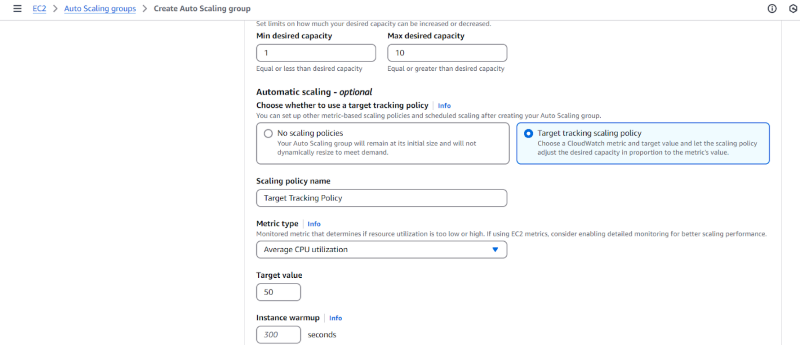

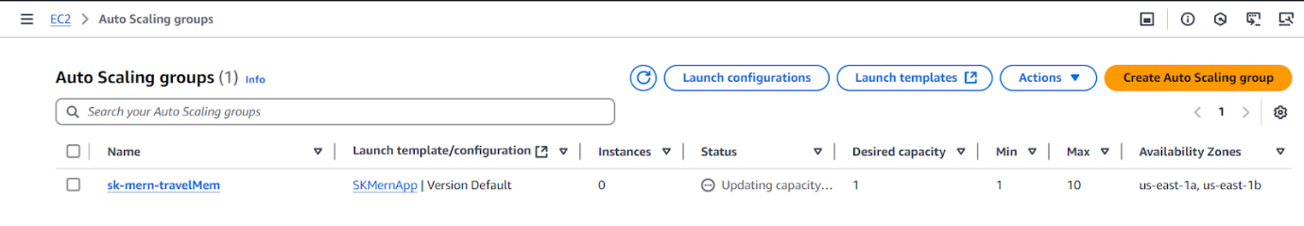

**Domain Setup with CloudFlare:**

Create a domain in any of the domain selling websites like Godaddy, namecheap etc.. and configure the domain in Cloudflare.

To connect the custom domain to the application using cloudflare using A record, navigate to cloudflare account -> DNS -> Records -> Add record

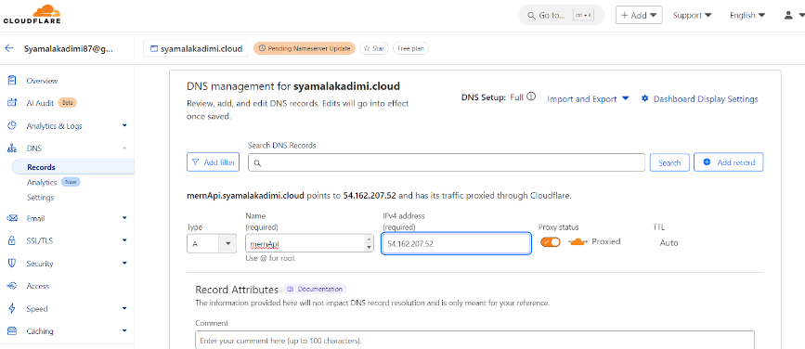

Navigate to the application to verify that the connectivity is working

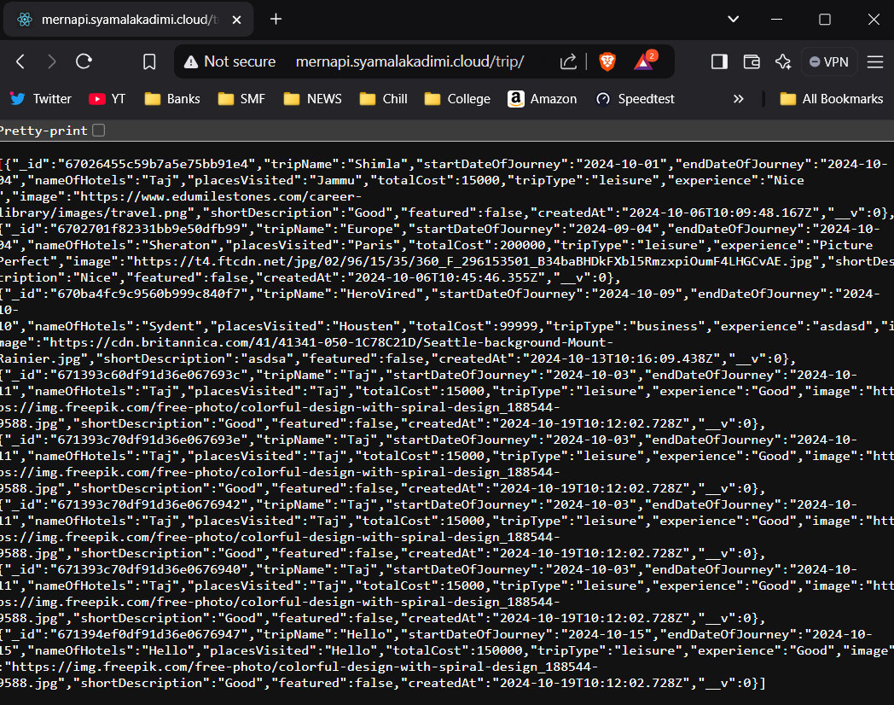

To connect the custom domain to the application using cloudflare using CNAME pointing to load balancer endpoint, navigate to cloudflare account -> DNS -> Records -> Add record

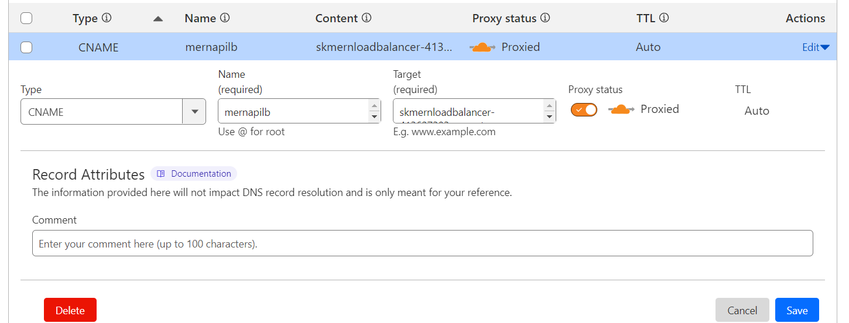

Navigate to the website to verify the application is accessible

